Homework 4 – Entropy Coding
314552046莊明憲
SPEC
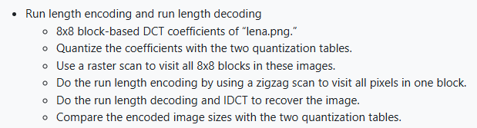
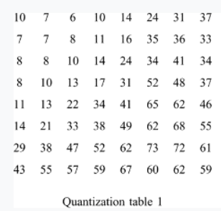 | 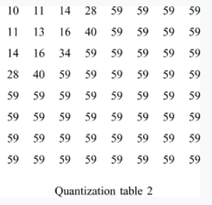
Ref: https://www.youtube.com/watch?v=Q2aEzeMDHMA
Ref: https://q-viper.github.io/2021/05/24/coding-run-length-encoding-in-python/
Code Explanation
- Zigzag Scan / Inverse Zigzag
These two functions convert an 8×8 block into a 1×64 sequence and reconstruct the block using the predefined zigzag index map. They ensure low-frequency coefficients appear first, which improves RLE efficiency.
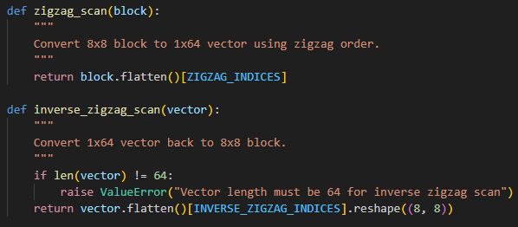
- Quantization Step
During encoding, each DCT block is divided by the selected quantization table and rounded. This step introduces controlled information loss and directly affects both compression level and reconstruction quality.
- Run-Length Encoding (RLE)
The RLE function scans the zigzag vector and converts consecutive zeros into (zero_count, value) pairs. An (0, 0) symbol is appended at the end of each block to mark EOB. 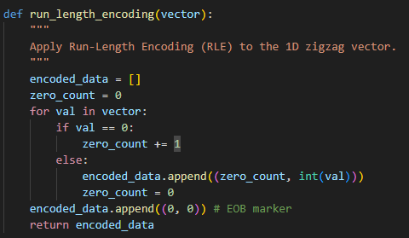
- Run-Length Decoding
The decoder reconstructs the 64-length vector by expanding zeros according to zero_count and inserting values. It stops when the EOB marker appears.
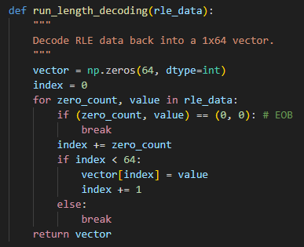
- Block Encoding Pipeline (encode_image)
For each 8×8 block, the code performs DCT → quantization → zigzag → RLE and stores the results. It also counts output RLE symbols to estimate the compressed size.
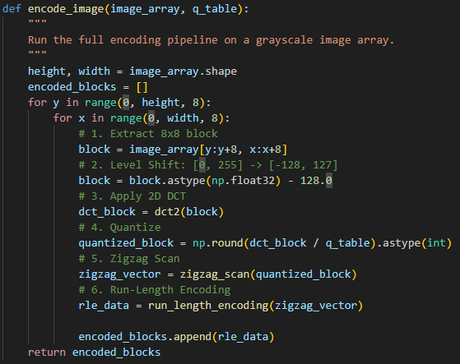
- Block Decoding Pipeline (decode_image)
The decoder reverses the entire process: RLE → inverse zigzag → dequantization → IDCT. Recovered blocks are placed back into the output image.
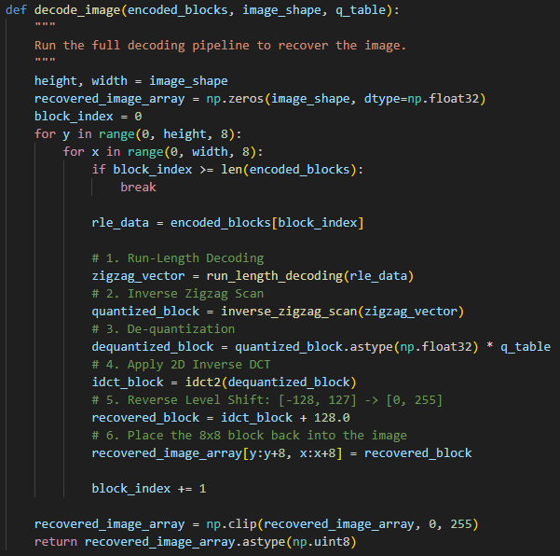

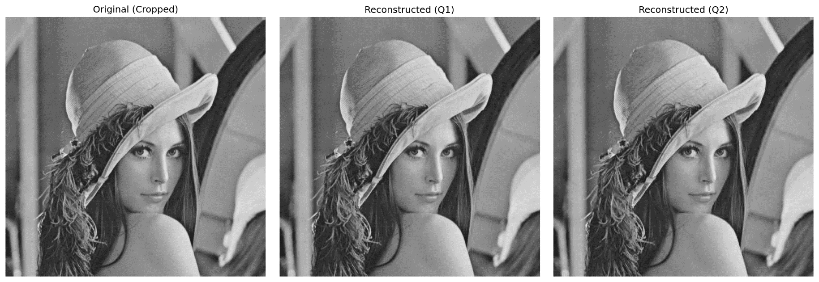
Comparison
Results 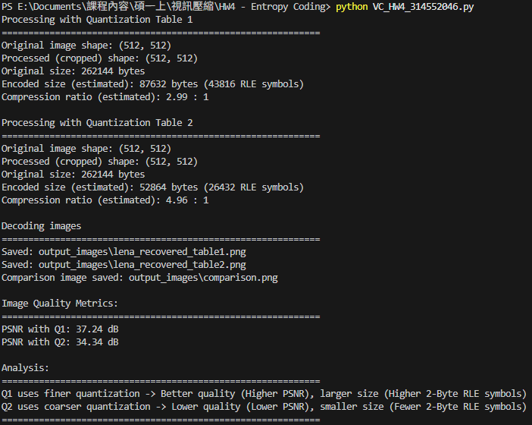
Analysis
Using Q1 results in higher-quality reconstruction and a larger encoded size because the quantization values are finer and fewer coefficients become zero. In contrast, Q2 uses stronger quantization, producing more zeros and shorter RLE runs, which leads to a smaller encoded size but lower PSNR. The results clearly show the expected trade-off: Q1 gives better visual quality, while Q2 provides better compression efficiency.

